 | ABES Engineering College, Ghaziabad  Department of Electronics & Communication Engineering  B. Tech (1st Year)
Annexure VIII (F)

Session: 2025-26 Semester: Ist Section: All
Subject Code: ……….. Subject Name: Basic Electronics Engineering

Tutorial Sheet-1

Date of Issue: ……………… Date of submission: ……….
S. No. | CO and KL | Description
 | CO1 and K2 | Explain the working of Zener diode as a voltage regulator against:  Fixed input voltage & fixed load resistance
 | CO1 and K3 | For the given circuit, find the output waveform.  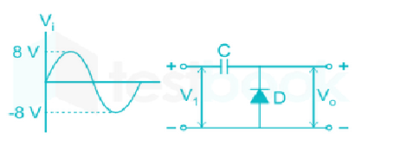
3. | CO1 and K3 | For the given clamping circuit, find the output waveform.  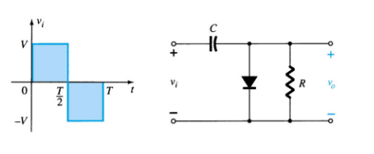
4. | CO1 and K3 | For the given clamping circuit, find the output waveform.  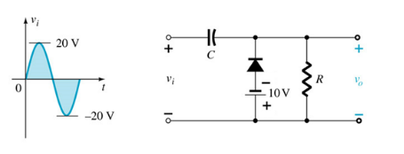
5. | CO1 and K3 | Determine & draw the output voltage of the given circuit.  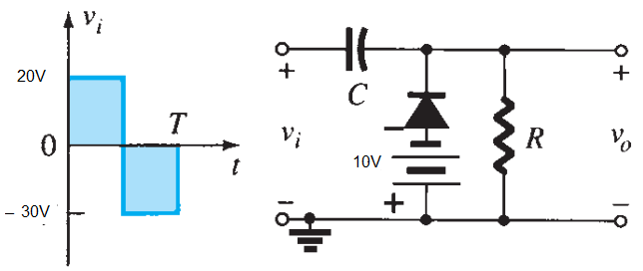

CO-Course Outcomes mapped with respective question
KL- Bloom’s Knowledge Level (K₁,K₂,K₃,K₄,K₅,K₆)
K₁ – RememberK₂ – UnderstandK₃ – ApplyK₄ – AnalyzeK₅ – EvaluateK₆– Create

